DOST TNA FORM 01 - Application for Technology Needs Assessment

Name of Enterprise:
Contact Person: | Position in the Enterprise:
Office Address: | Tel. No. | Fax No.
 | E-mail Address:
Factory Address: | Tel. No. | Fax No.
 | E-mail Address:
Website:

GENERAL AGREEMENTS:

- The applicant shall, at the earliest opportunity, make available to DOST Regional Office No. XII (DOST XII) all information (manuals, procedures, etc.) required to establish the technological status of the selected core business functions and management systems;

- If DOST XII is not satisfied that all the requirements for business registration are complied with, it shall inform the applicant of the observed deficiencies before starting the assessment;

- When the required inputs to the assessment are already supplied by the applicant, including Attachment A, DOST XII will assess the firm through the core business functions and management systems, whichever is applicable, to identify technological needs and verify compliance to standards vis-a-vis existing practices;

- When DOST XII has completed the technology assessment, a report will be prepared on the results of the assessment with accompanying recommendations and opportunities for improvement. The report prepared will define the scope of activities, functions, management practices and locations assessed. The applicant shall not claim or otherwise imply that the report applies to other locations, products or activities not covered by the report;

- The applicant agrees that the report will not be used until permission has been granted by DOST XII;

- The applicant agrees that the receipt or acknowledgment of the report ends the assessment stage; any technical assistance ensuing from the recommendations of the report will be viewed as a separate project.

UNDERTAKING

I agree to undertake and observe the above General Agreements as stipulated by the Department of
Science and Technology Regional Office No. XII.

Signature over Printed Name

Position in Enterprise

Date

Attachment A

Enterprise Profile

Name of Enterprise Production Site/Location _______________________________________________________________ Business Permit No.__________________________________Year Registered Brief Enterprise Background

Year enterprise was established: Initial
_______________________________________________capitalization: _____________________
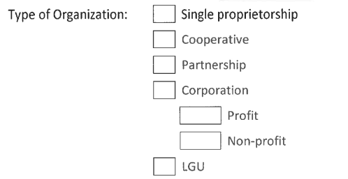

Enterprise Registration No.
_______ Year Registered

Classification according to capital (PhP)

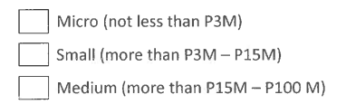
Present
capitalization

Classification according to employment (number of employees) Micro
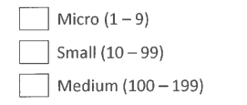

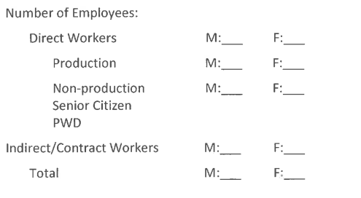

Business Activity (please specify SECTOR and COMMODITY):

- Specific product or service the enterprise offers its customers:

- Reasons why assistance is being sought:

- Have you consulted any other individual/organization for any assistance?
If Yes, which company/ agency?
_____________________________________________________________________
Please specify the type of assistance sought

If No, why not?

Organizational Structure

- Enterprise's plan for the next 5 years?

Next 10 years?

- Current agreements and alliances undertaken

BENCHMARK INFORMATION

- Production and Supply Chain
  - Raw Material

Raw Material | Source | Unit Cost (P.) | Volume Used/Year

  - Production

Product | Volume of Production/Year | Unit Cost of Production (.P.) | Annual Cost of Production (.P.)
  - Existing Functional Production Equipment

Type of Equipment | Specifications | Capacity | No. of Units | Year Acquired
Production Problems and Concerns

  - Production Waste Management System

  - Production Plan

  - Plant Lay-Out

  - Process Flow

- Inventory System

- Maintenance Program

- cGMP/HACCP Activities

- Supplies/Purchasing System

- Marketing
- Marketing Plan

- Market Outlets and Number

- Promotional Strategies

- Market Competitors

- Packaging
  - Nutrition Evaluation
  - Bar Code
  - Product Label
  - Expiry Date

- Finance
- Cash Flow or other related documents

- Source(s) of capital/credit

- Accounting System

- Human Resources
- Hiring and Criteria

- Incentives to Employees

- Training and Development

- Safety Measures Practiced

- Other Employee Welfare

- Other Concerns

Prepared by: Validated by:

Printed Name and Signature of Owner/Chair/Representative
____________________ Date

Printed Name and Signature of
PSTD/CASTD/CSTD

______

